Practical
SUMMARY:-
Kruskal’s algorithm is used to find the Minimum Spanning Tree (MST) of a connected, weighted graph. It sorts all edges in increasing order of weight and selects the smallest edges without forming a cycle. The total cost is calculated by adding the weights of the selected edges.

Output:
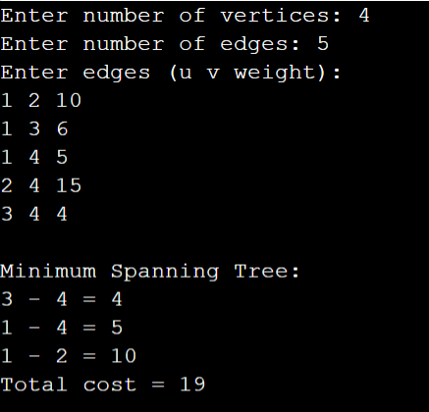

Time Complexity:
Case | Time Complexity
Best Case | O(E²)
Average Case | O(E²)
Worst Case | O(E²)

Space Complexity:
(O(V+E))
Here, (V) is the number of vertices and (E) is the number of edges. The program stores the edges and the parent array.

Conclusion:
Thus, Kruskal’s algorithm was successfully implemented in C to find the Minimum Spanning Tree and calculate its minimum total cost without forming cycles.

